Major Boss Template - Basic Info

DUE DATE: [TO UPDATE]

# Summary of the deliverables

In an interdisciplinary team, you are to investigate a real-life problem and identify a solution that you can design and produce with the skills you have in your team. You are to deliver:

* A digital technology **product**
* A **report** (website, presentation, video), covering the **product** and your **project** (under Project Document, see further down)

This document will take you through the necessary steps to plan, analyse, design, develop and test your product and report.

# Team Name: Teem BeanCat

# Team Members: 2-4 people

|  |  |  |
| --- | --- | --- |
| # | Name | Specialty (must be related to what you have learned this semester) |
| 1 | Ben D’Cruz | Unity/C# |
| 2 | Ben McGaw | Unity/C# |
| 3 | Nigel Quick | Python |
| 4 |  |  |

Your team must cover the following required skills:

1. Coding and/or robotics
2. Web development

You must also have someone capable of producing a decent **presentation** (PowerPoint, Keynote, Prezi, etc.), or **video** (screencast, live actions, or animated), especially if you do not have a web developer.

# Communication Plan

## Communicate

**How are your team planning to communicate with each other?**

Discord & GitHub

## Collaborate

**How are your team planning to collaborate with each other?**

GitHub

## Sharing of work

**How are your team planning to share the work?**

GitHub

## Backup of work

**How are your team planning to back up the work?**

GitHub – it’s their problem not ours (also have it on multiple computers)

**It’s important that these details are worked out and the development environment is set up BEFORE any work is done!**

**The following section needs to be completed sequentially.**

Major Boss Template - Project Document

# Real-Life Inspirations

**What motivates you to take on this boss. If you’re inspired by one of the UN Sustainable Development Goals (SDG), you must mention it here.**

The loss of species is a disaster for mankind.

This is because a lot of different species rely on each other for food, and when one is removed it can cause a cascading affect and other species can become extinct. This problem is caused by the widespread lack of thought towards the environment, these issues can include things like deforestation, global warming and pollution.

# Overview of the major boss challenge

**What is the challenge and what is your solution meant to achieve? What is the problem you’re actually trying to solve with your solution? Who will benefit from your solution? How? What are their needs?**

**This is NOT the “real-life” challenge, this is the actual solution you’re trying to develop.**

Our solution is to spread awareness by creating a simulation that represents an ecosystem as closely as possible, with multiple interdependent species with different traits. The simulation will be interactive so the user can interact with the world once it reaches a stable population. The user will then see what one small change can do to the rest of the ecosystem.

Your solution MUST AT LEAST satisfy the following MINIMUM REQUIREMENTS:

* It must make use of everyone’s specialities in a significant way.
* It must produce a report – either a website, a presentation or a video. ***All the sections under Project Document*** *must appear in that report* alongside any other information you may wish to include about the **actual product**. (This is why you must write this document carefully as you can just copy and paste its content into your report later. Just linking this Word file is NOT enough :D.)
* It must produce a “product” of digital technology (hardware or software or both but a website alone is not acceptable unless it is a “smart” or interactive website with scripts that perform some function other than displaying information, i.e. a web app).

TIP: It’s a good idea to incorporate your mini-bosses to this work to reuse your previous code/experience. Adapt and extend.

# Specifications

In this section, you will need to create and maintain (regularly update) a **list of features** that you are planning to deliver at the end of the project.

You must also state clearly **who** has been responsible for which feature, this will encourage fair sharing of the workload and *different people may end up with different grades*.

The column for estimated **time** of completion encourages you to plan carefully. Things probably won’t turn out the way you want but at least you are aware of how much time some features may cost your team.

## Product

|  |  |  |  |
| --- | --- | --- | --- |
| # | Feature | Responsibility Of | Estimated Time Of Completion |
| 1 | The unity game | Ben2 + a bit of Nigel for some random bugfixes |  |
| 2 | Launcher (python) | Nigel |  |
| 3 | Python game | Nigel |  |

## Report

Remember, the report has two purposes – to showcase your “product” AND to document your team and the project.

|  |  |  |  |
| --- | --- | --- | --- |
| # | Feature | Responsibility Of | Estimated Time Of Completion |
| 1 | Project Document (this one) | Collaborative |  |
| 2 | Presentation | Nigel |  |
|  |  |  |  |

# Special equipment

A list of any special equipment you will need to build your product. It’s very important to negotiate with your teacher(s) to make sure these are available and reserved for your team before developing anything!

|  |  |
| --- | --- |
| Name | Planned Purposes |
| None |  |
|  |  |

# Visual Design

In this section, you will **present the evidence of your design process**, regarding the deliverables (product and report). Before and during your actual development of the deliverables, you must use the various design techniques taught in the modules to visualise how the various components will fit together.

You will also need to include sufficient annotations (notes) in your design to help communicate your ideas amongst team members and with your teacher(s).

## Product

DESIGN 1: 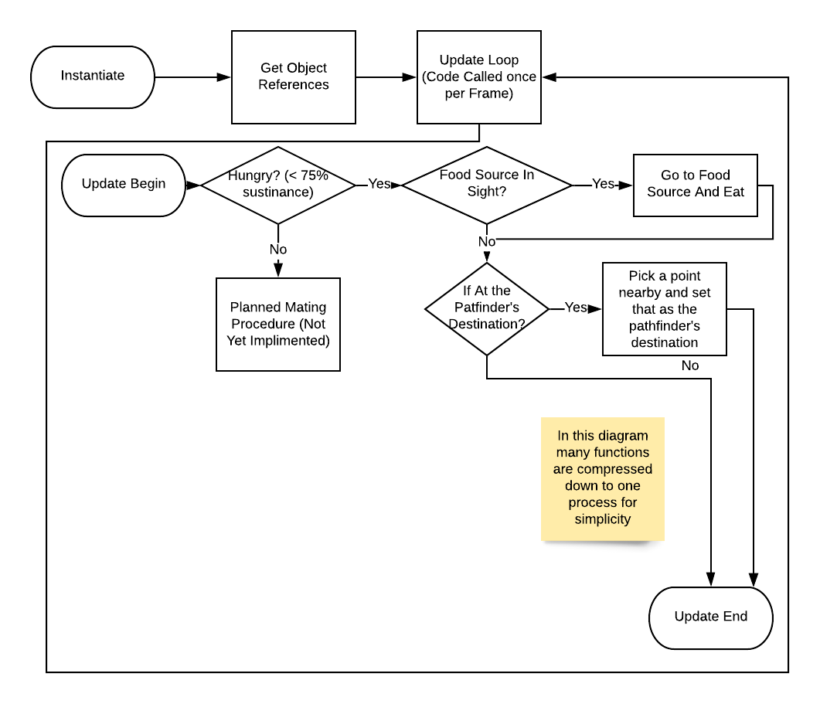 Animal behaviour process.

## Report

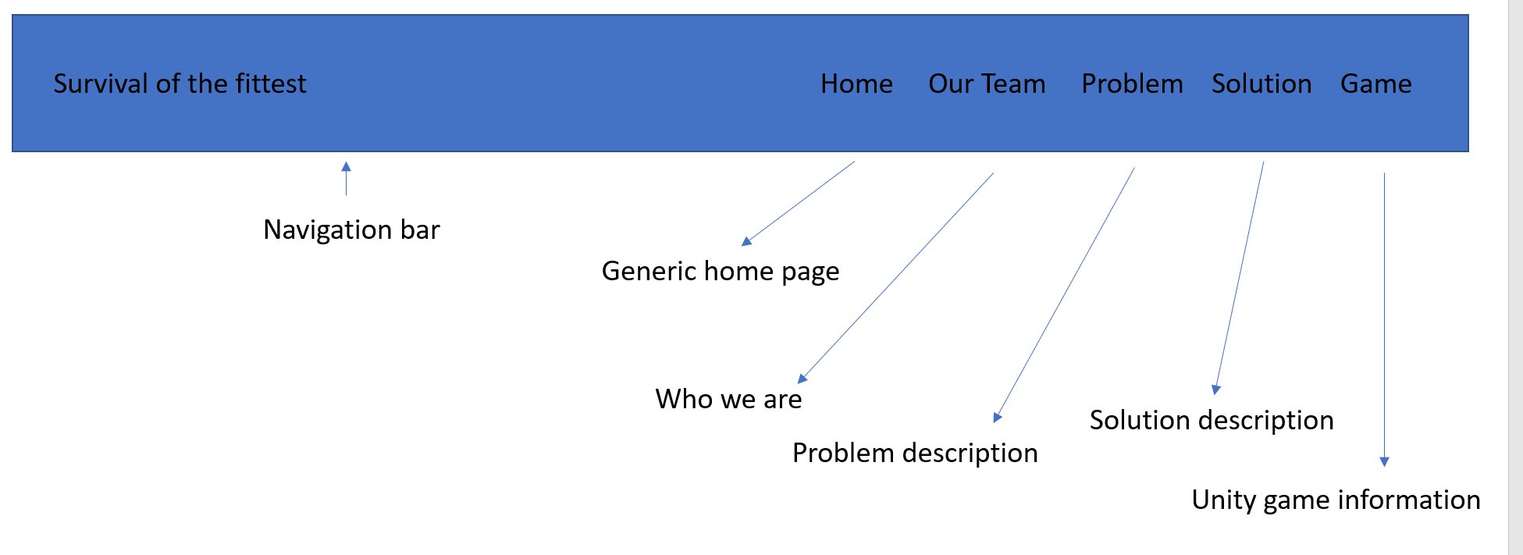

Presentation page map

# Interview & Negotiation

When you reach this step, you must contact your teacher(s) to arrange for an interview. Please **email** your request to your teacher(s) with a **copy of this Word document**, completed up to this point.

Your teacher(s) will interview your team to make sure you are ready for the project. This is your opportunity to negotiate with the teacher(s) to make sure you are fully supported in what you are doing. If you need any **special equipment**, now is the time to ask for it!

You should also clarify with your teacher(s) **exactly what you will need to submit** for this project (listed in the **Development** section below and in the **Design** section above).

# Development

You are now ready to develop your product and report. Please maintain the **following list of deliverables** to allow your team and your teacher(s) to keep track of what you will submit.

Make sure to leave nothing out!

|  |  |  |
| --- | --- | --- |
| # | To Submit | How To Submit |
| 1 | This Word document | GitHub |
| 2 | The unity game | GitHub |
| 3 | Presentation | GitHub |
| 4 | Python game | GitHub |

Generally, you will need to submit this Word document, the source files of the product and the report, in whatever form. ***Note that files larger than 100 Mb should ideally be handed in to the teacher(s) on a USB drive.***

# Testing

In this section, you will **present the evidence of your testing** of the product and the report. You may **copy and paste some information from the Specifications** section above.

## Product

|  |  |  |  |  |  |
| --- | --- | --- | --- | --- | --- |
| # | Feature | Tested By | Passed? (Y/N) | Last Tested On (we tested all these again just before the presentation to make sure that worked) | Notes |
| 1 | Camera switching | Nigel | Y | 7th Nov |  |
| 2 | Stat bar functionality | Ben M | Y | 7th Nov |  |
| 3 | Player movement | Ben D | Y | 7th Nov |  |
|  |  |  |  |  |  |

## Report

|  |  |  |  |  |  |
| --- | --- | --- | --- | --- | --- |
| # | Feature | Tested By | Passed? (Y/N) | Last Tested On | Notes |
| 1 | Presentation page switching | Nigel | Y | 1st Nov | It works! |

# Evaluation & Reflection

Complete the Evaluation & Reflection task on Canvas. Every team member should ideally complete this before the final presentation.

# Presentation & Peer Assessment

Your team will need to present your project in front of the class. Ideally you should keep your presentation to around 5 minutes. You will need to present both your report and the product in any manner that enlightens and impresses your peers.

You should anticipate questions from your teacher(s) and the other teams.

The other teams will assess your work using **a survey and a discussion**. The average of the peer assessment results for your work will contribute up to 20% of your final result. The other 80% comes from your teacher(s).

Naturally, you will have to provide your assessment for all the other teams as well!

Check out the rubric for this challenge as well as the content of the “Major Boss Challenge” module for more details.

# Submission

To upload to Canvas (**one person per team can do this**) – make sure to hand in everything specified in the Development section above. It’s a very good idea to keep everything inside a shared cloud storage location (i.e. OneDrive) so you can just **submit a URL!**